2000 Summer

Path 26 (Midway-Vincent)

Operating Transfer Capability Increase Study Report

Submitted to

California Operations Studies Subcommittee
&
Operating Transfer Capability Policy Group

By

California Independent System Operator
Mark Willis
Chuck-yan Wu

August 16, 2000

Executive Summary

The purpose of this study is to support the increase of the Operating Transfer Capability (OTC) of Path 26 to its full rating of 3000 MW from the currently approved OTC of 2800 MW for the remaining 2000 Summer operating season.

Path 26 (Midway – Vincent 500 kV lines #1, #2, and #3) was thermally limited by the emergency rating (3000 Amps, or 2800 MW) of the wavetraps in the Midway – Vincent #3 500 kV line at the Midway and Vincent for the loss of #1 & #2 lines. PG&E and SCE had recently submitted to CAISO an updated emergency rating for the wavetraps, thus enabling Path 26 be loaded to its pre-contingency full WSCC path rating of 3000 MW.

The impact of Path 26 flow at 3000 MW to the existing nomogram operations (COI/DC, and SCIT) were studied using the 2000 summer nomogram point cases. Study results, showed in Tables 1 and 2, indicated that the increase flow on Path 26 have NO significant impact on the simultaneous limits of the current OTCs and nomogram operations of COI/DC and SCIT:

- Post-contingency flows are all within emergency limits.
- All major buses that are monitored maintained their post-contingency var margins.
- The system is stable.
- Study Methodology is attached

Path | Summer 2000 OTC
COI (N-S) | 4,600MW*
PDCI (N-S) | 3,100MW*
Path 26 | 3,000MW
SCIT | 13,000MW*
Maximum SDG&E Import | 2,750MW* | 3,050MW*
Maximum CFE Import | 400MW* | 3,050MW*

* No change in OTC.

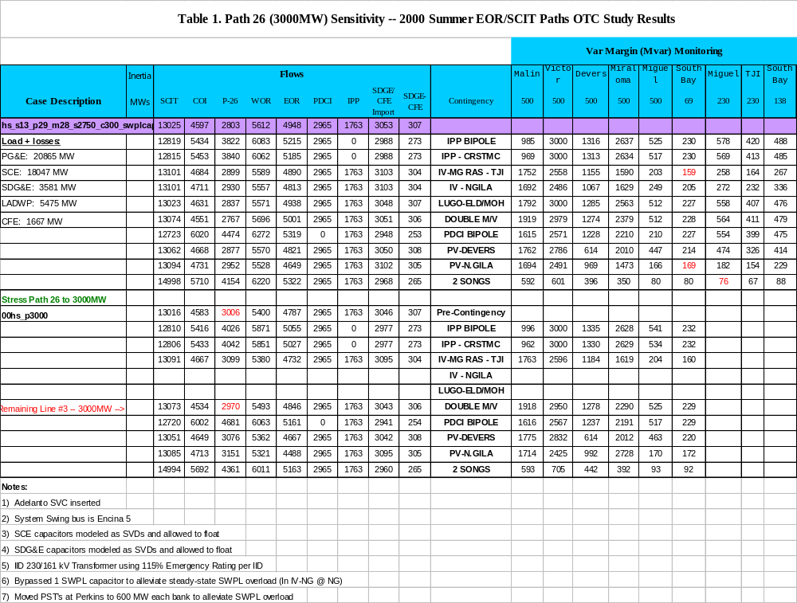

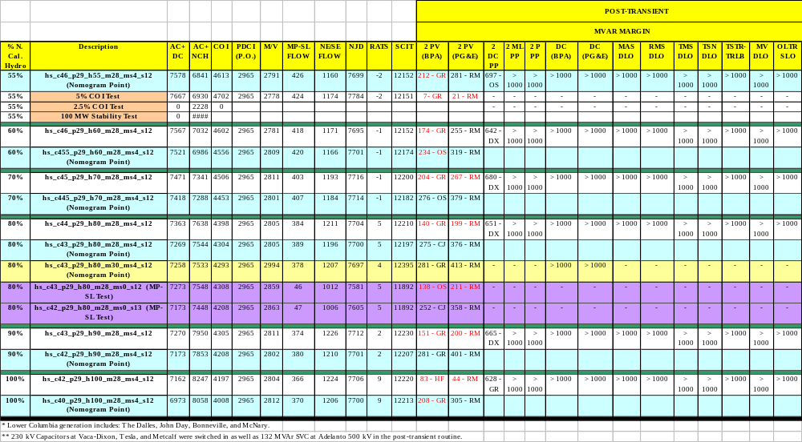Table 2. Impact to AC/DC Nomogram Operation

Attachment: Study Methodology

Background
The purpose of this study is to verify the operating transfer capability of COI, PDCI, Path 26, SCIT and SDG&E/CFE total import limitations for the 2000 Summer operating season.

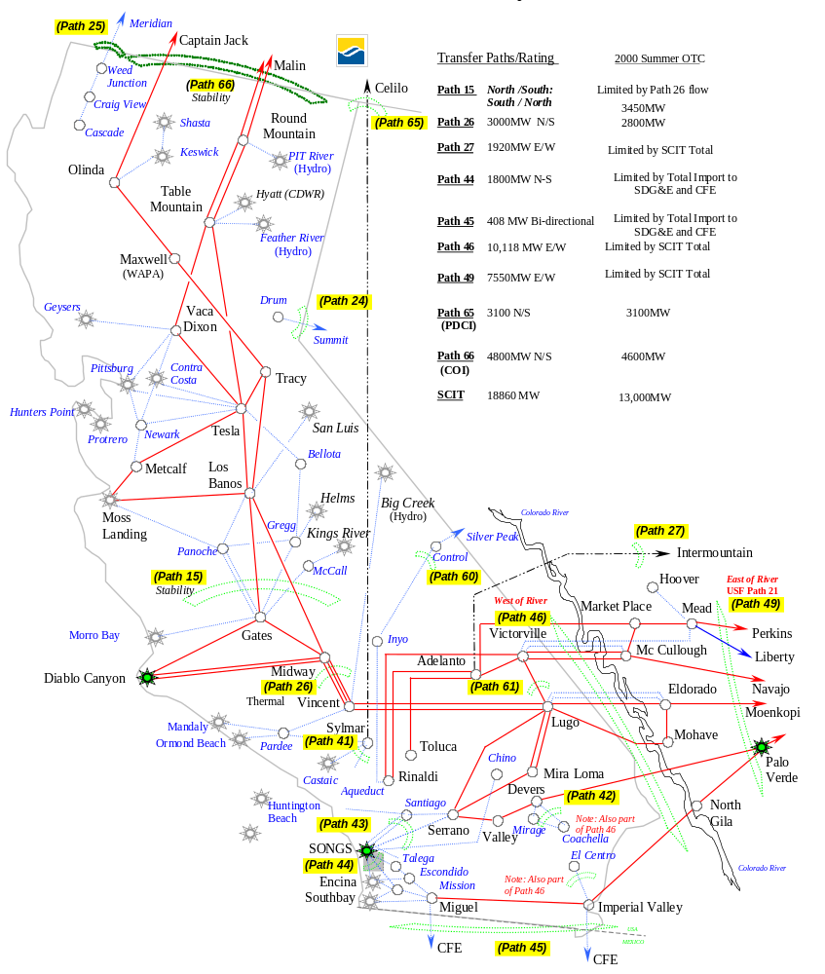California EHV Transmission System

Methodology

The WSCC reliability criteria, the WSCC voltage stability criteria, and member reliability criteria as appropriate were used to evaluate the adequacy of study results.

General Methodology

- The basecases used in this study were developed from the OTC 00hs03b case.
2. Governor action will be assumed throughout the WSCC system for generator outage(s).

Steady-state

- No system element is loaded more than 100% of its continuous thermal rating under pre-contingency conditions.
- No system element is loaded more than 100% of the emergency thermal rating after a contingency.

Transient Stability
- Transient stability runs will be run out to 20 seconds to ensure the system is stable and positively damped.
- Steam governors will be blocked as per the TSS recommendation
- The load type will be submitted by the utilities during the base case development process. The default load type for the NW and BC-Hydro areas will be set at 100% constant current for P and 100% constant impedance for Q.
- Acceleration Trend Relay (ATR): Suspected ATR action will be verified by Montana Power Company if there is an indication of separation between Montana and the Northwest neighboring areas, or there are sustained low voltages in the Montana area or on its interties. Information required will be the accelerating power, machine angle, speed and MW loading for each Colstrip machine. The GE program has a model for the ATR that has not been verified by Montana. However, it may give an indication when a Colstrip unit trip is needed.
- Additional RAS used in transient stability analysis:
- Insert 21 ohms Fort Rock series capacitors (fast insertion) between Grizzly and Captain Jack, Grizzly and Malin, Buckley and Summer Lake.
- Refer to an updated table Northwest Generator Drop for Bipolar PDCI Outage (n-s) for amount and timing of generator dropping in Northwest.
- Drop filter banks at Celilo and Sylmar (the MVAR levels dropped will depend upon the DC schedule).

Insert 400 MVAR of MSC @ Malin, 200 MVAR shunt capacitor @ Olinda, 600 MVAR shunt capacitor @ Tracy, 454 MVAR shunt capacitor @ Table Mt.
- The WSCC Reliability Criteria for Transmission System Planning will be observed for the transient stability results.

Post transient

- Margin: In compliance with the new TSS Margin Criteria, the operating transfer capability study will meet the N-1 reactive margin criteria, and the N-2 criteria will be assumed (50% of N-1). In particular, North of Malin, the Northwest 500 kV bus reactive margin requirement is 600 MVAR for N-1, and 300 MVAR for N-2. In California, (except SDG&E) all 500 kV bus reactive margin requirement is 500 MVAR for N-1 and 250 MVAR for N-2. SDG&E’s reactive margin requirement is 150 MVAr for N-1 and 75 MVAr for N-2 for all buses 230 kV above and at generating plant buses.

- Power margin test will be performed on all paths being studied. This would include stressing the path 5% for N-1 and 2.5% for N-2. The system needs to have positive reactive margin.
- Double generator outages are required to meet WSCC Performance Level C.
- A maximum voltage dip of 5% in Idaho, Utah, and Southern Oregon system.
- Additional RAS used in post-transient:
- remove all Sylmar filter banks.
- insert 175 MVAR shunt capacitor @ Kinport if the voltage drops to 0.96 p.u. and sustains for 3 seconds.
- Insert 126 MVAR shut capacitors @ Vaca-Dixon 230, 252 MVAR @ Tesla 230, and 375 MVAR @ Metcalf 230 based on local voltage control
- Insert 132 MVAR SVC at Adelanto if Adelanto voltage dip beyond 5%.
- IV-Miguel line outage RAS updated to cross trip Miguel-Tijuana 230 kV Line.

Other

- The maximum permissible 2700 MW generator drop in the Northwest is an integral part of the RAS, which mitigates the impact of a PDCI bipolar outage.
- Northwest FACRI is available to all contingencies.

Study Results

Contingency Screening
The worst contingencies in California including the following:
- 2 PV unit Outage
- Bipolar outage of the PDCI
- Table Mountain South Double Line Outage
- 2 SONGS unit Outage
- SWPL Line Outage/with RAS
- 2 Diablo Canyon unit Outage
- 2 Moss Landing Unit Outage
- 2 Pittsburg Unit Outage

- AC/DC/Northern California Hydro Nomogram
For Northern California the worst contingency is the loss of 2 PV units (G-2), the loss of PDCI Bipolar (N-1), the loss of 2 Moss Landing Units, and the Table Mountain South Double Line Outage (N-2). The limiting factor is the reactive margin at Round Mountain and various Northwest 500 kV buses (Grizzly 500) for loss of 2PV units.

SCIT Nomogram
For SCIT and Southern California, the worst contingencies are the loss of 2 SONGS units (N-2), loss of IV-Miguel (cross trip Miguel-Tijuana 230), and the loss of PV-N.Gila line. The limiting factor is the reactive margin at the South Bay 69 kV bus in SDG&E.

The study results are based on Midway-Vincent flow of 3000 MW and COI flow of 4600 MW. SDG&E/CFE total import of 3050MW.

A sensitivity study analyzing the potential relationship between the SCIT and the SDG&E/CFE Import was conducted. The SDG&E/CFE Import was reduced to 2,145 MW from 3,050 MW, and the SCIT was raised until the reactive margin criteria was satisfied for the loss of two San Onofre Nuclear Generating Station units. The inertia in Southern California (LADWP, SCE, and SDG&E) remained constant between the OTC study and the sensitivity. The results illustrated that the SCIT could achieve a minimum of 15,500 MW. However, the results are based on additional generating units in the Southern California Edison (SCE) area beyond both the required Reliability Must-Run (RMR) generating units and units required to meet load in Southern California Edison area. These additional generating units would not necessarily be on-line unless provided by the market, and would not be required on-line for RMR. Studies were also analyzed without the additional generating units in the SCE area with the 2,145 MW SDG&E/CFE Import, and the SCIT remained approximately unchanged.

